

The ARRIVE Guidelines Checklist
Animal Research: Reporting In Vivo Experiments
Jin-Shan Ran^{1#}, Ling-Qian Yin^{1#}, Jing-Jing Li¹, Yan-Qiang Tang², Jian Huang², Peng Ren¹, Xian-Xian Zhang¹, Zhi-Qiang Li¹, Si-Ming Li², and Yi-Ping Liu^{1*}
¹Farm Animal Genetic Resources Exploration and Innovation Key Laboratory of Sichuan Province, Sichuan Agricultural University, Chengdu Sichuan 611130, China.
²Institute of Animal Husbandry and Veterinary Sciences, Jiangxi Academy of Agricultural Science, Nanchang, 330200, Jiangxi, China.
 |  | ITEM | RECOMMENDATION | Section/  Paragraph
 |  |  |  | Title
 |  |  |  | Abstract
 | INTRODUCTION
 | 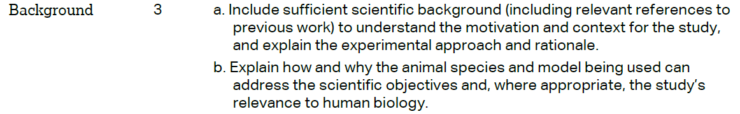 |  |  | Backgroud,paragraph 1,2,3
 |  |  |  | Backgroud,paragraph 4
 | METHODS
 |  |  |  | Methods, Animals paragraph 1
 | 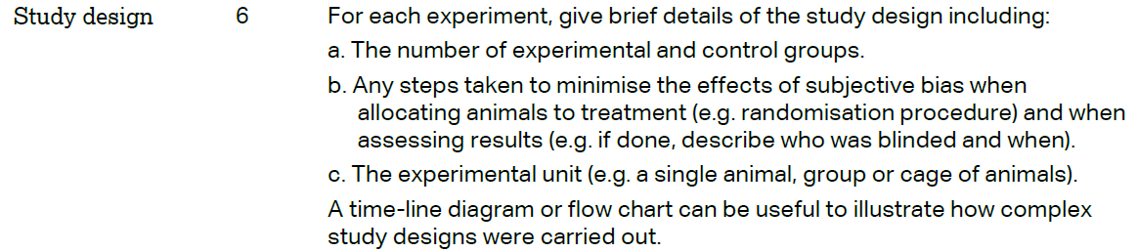 |  |  | N/A
 | 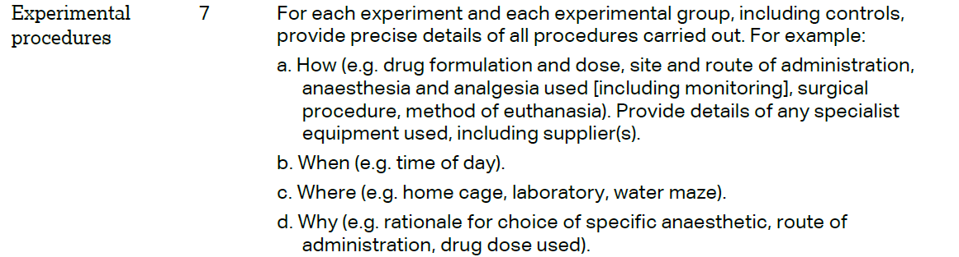 |  |  | N/A
 | 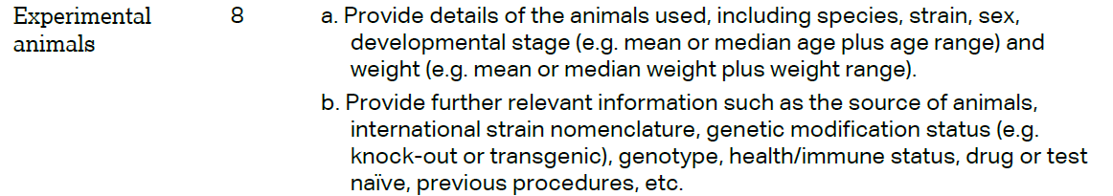 |  |  | N/A
The ARRIVE guidelines. Originally published in PLoS Biology, June 2010¹
 | 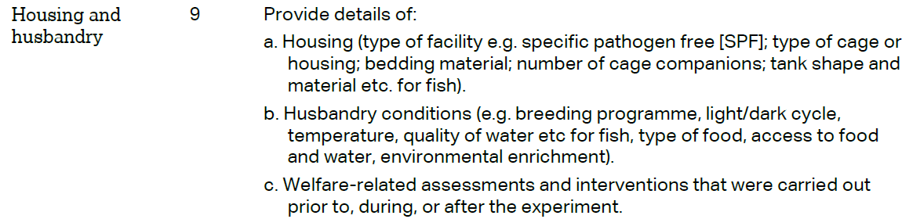 | N/A
 | 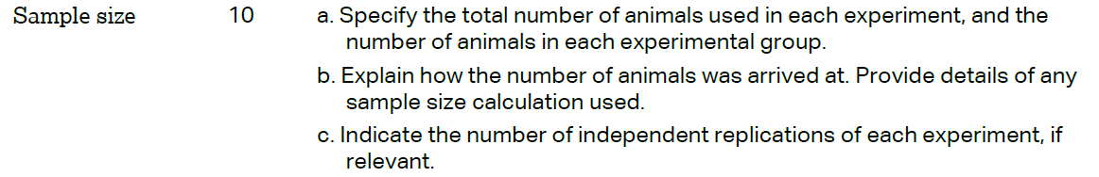 | N/A
 | 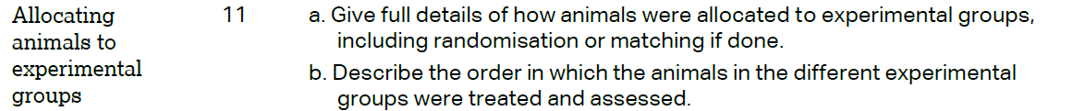 | N/A
 |  | N/A
 | 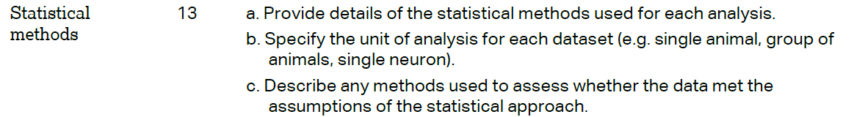 | Methods, Statistical Analysis paragraph 1
 | RESULTS
 |  | N/A
 |  | N/A
 |  | N/A
 |  | N/A
 | DISCUSSION
 | 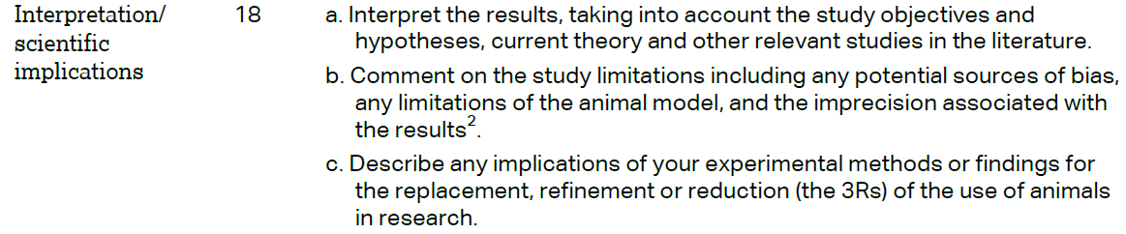 | N/A
 |  | N/A
 |  | Funding, paragraph 1

